The quality and reliability of short videos about developmental dysplasia of the hip on TikTok and Bilibili: A cross-sectional study

Ping Yan¹ , Ying Tang², Lichun Hua^{2*}

¹Department of Orthopedic Surgery, Children’s Hospital of Nanjing Medical University, Nanjing, Jiangsu, China
²Department of Ultrasound, Children’s Hospital of Nanjing Medical University, Nanjing, Jiangsu, China
*Correspondence: Lichun Hua
Email: lichunhua2025@126.com
Address: 72 Guangzhou Road, Nanjing, Jiangsu, China

Abstract
Objective: To assess the quality and reliability of short videos about developmental dysplasia of the hip (DDH) on TikTok and Bilibili, two popular Chinese platforms.
Methods: A cross-sectional study of 125 DDH-related videos from TikTok (82 videos) and Bilibili (43 videos) was conducted. Video characteristics, author types, and interaction metrics were analyzed. Video quality was assessed using the modified DISCERN (mDISCERN) and Global Quality Score (GQS).
Results: Bilibili videos outperformed TikTok in terms of quality (higher GQS and mDISCERN scores). Author professionalism and video duration were significant positive predictors of quality. Paradoxically, higher interaction metrics (likes, shares, comments) were negatively correlated with video quality.
Conclusion: The study underscores the impact of author professionalism and video length on quality. Despite their popularity, videos with higher engagement often lack scientific rigor, pointing to the need for improved content moderation on short video platforms.
Keywords: DDH, Short Video Platforms, Health Information Quality, cross-sectional study

Introduction
Developmental dysplasia of the hip (DDH) is a common pediatric skeletal disorder, especially among infants[1]. If untreated, DDH can lead to severe motor dysfunction and joint degeneration, increasing the likelihood of hip replacement in adulthood[2]. Early recognition and intervention are crucial for better prognosis. In the digital age, platforms like TikTok and Bilibili have become important sources of health information, offering accessible content for parents[3]. However, the quality of this information is often inconsistent and may be misleading, delaying timely diagnosis and treatment[4, 5]. This study evaluates the quality of DDH-related videos on these platforms to enhance public health education and content regulation.
Materials and Methods
Search Strategy and Data Extraction
We used Chinese search terms "developmental dysplasia of the hip," "pediatrics," and "hip dislocation" on Bilibili and TikTok. To minimize bias, searches were performed using incognito mode and new accounts. The top 100 default-sorted videos from each platform were collected. Inclusion required relevance to DDH etiology, diagnosis, treatment, or prevention, with exclusions for advertisements, irrelevant content, and recent uploads. Key variables extracted included platform, upload date, author type, video type, interaction metrics (likes, comments, shares, views), and video duration. Author expertise was categorized into four levels, and videos were classified as basic knowledge, case reports, or treatment processes.
Video Quality Assessment
Video quality was assessed using the modified DISCERN tool and the Global Quality Score (GQS).[6]. The mDISCERN tool evaluated five criteria (clarity, relevance, rigor, traceability, impartiality) on a 0-5 scale. GQS assessed overall quality using a 5-point scale. Videos with mDISCERN scores below 3 or GQS below 3 were deemed low quality. Independent raters reviewed the videos, with discrepancies resolved by a third arbitrator. All assessors underwent standardized training.
Statistical Analysis
Descriptive statistics and non-parametric tests were used for analysis. Differences in platform distribution and quality scores were assessed using chi-square and Mann-Whitney U tests. Inter-rater agreement for mDISCERN and GQS scores was quantified using Cohen's kappa coefficient. All analyses were performed using IBM SPSS Statistics 27.0.

Results
Video Characteristics
A total of 125 short videos on DDH from TikTok (82 videos) and Bilibili (43 videos) were analyzed (Figure 1), revealing significant inter-platform differences across various characteristics (Table 1). TikTok videos were predominantly created by individual medical professionals (87.8%) and focused on "Case reports and related discussions" (51.2%), while Bilibili featured a more diverse authorship, with 44.2% from individual medical professionals and 27.9% from non-medical institutions, predominantly covering "Basic knowledge of the disease" (62.8%).

Figure 1. Search strategy for videos on DDH.
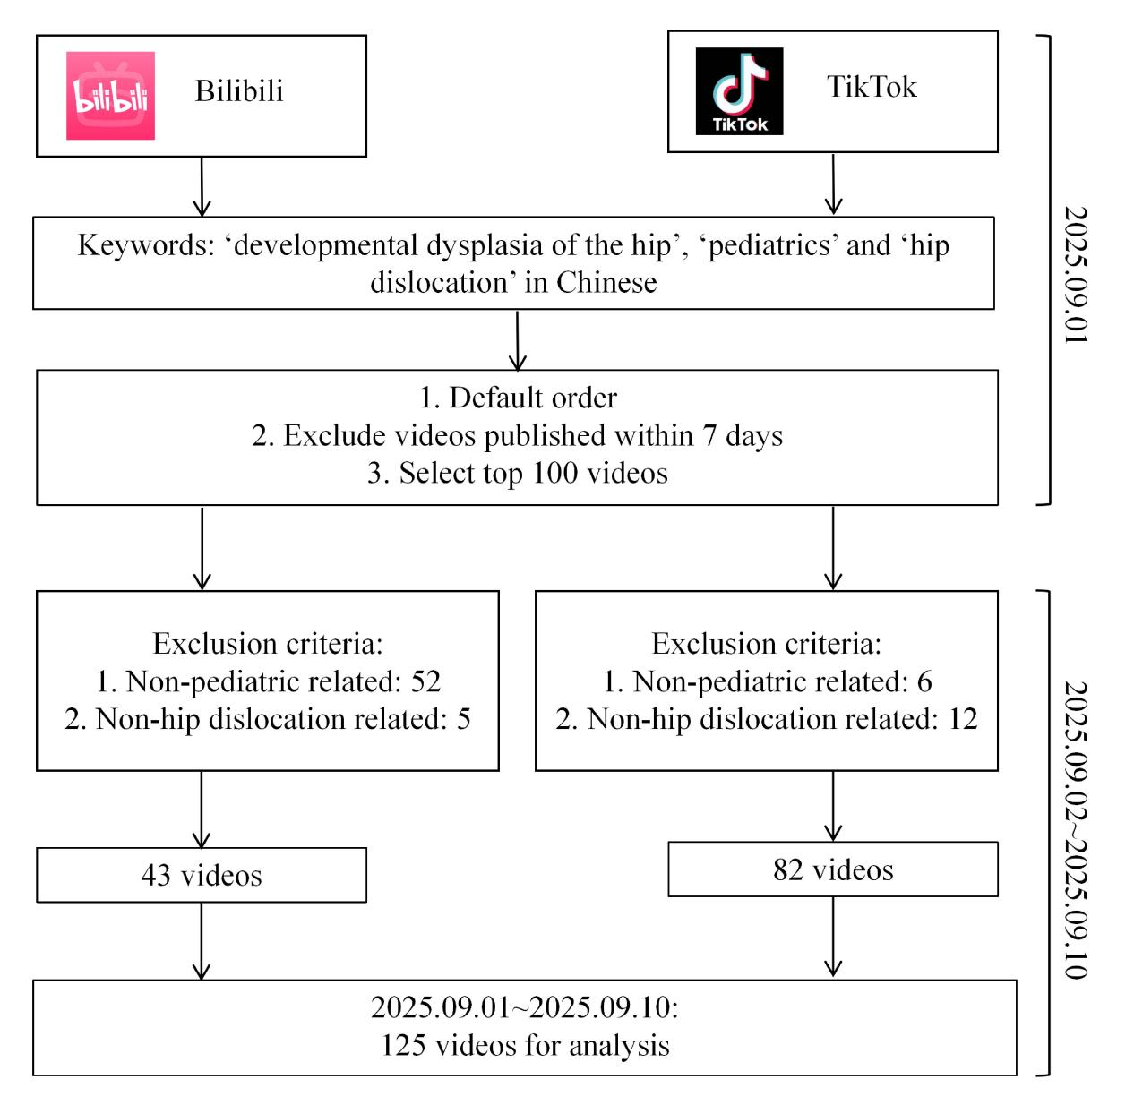
Table 1. Characteristics of videos about DDH on TikTok/Bilibili.
Characteristic | TikTok (n=82) | Bilibili (n=43) | P-value
Upload year [n (%)] |  |  | ＜ 0.0001
2020 and before | 0 (0.0%) | 8 (18.6%)
2021 | 3 (3.7%) | 10 (23.3%)
2022 | 14 (17.1%) | 6 (14.0%)
2023 | 23 (28.0%) | 10 (23.3%)
2024 | 18 (22.0%) | 2 (4.7%)
2025 | 24 (29.3%) | 7 (16.3%)
Video source [n (%)] |  |  | ＜ 0.0001
Non-medical professional institutions | 0 (0.0%) | 12 (27.9%)
Medical professional institutions | 2 (2.4%) | 5 (11.6%)
Non-medical professional individuals | 8 (9.8%) | 7 (16.3%)
Medical professional individuals | 72 (87.8%) | 19 (44.2%)
Video type |  |  | ＜ 0.0001
Basic knowledge of the disease | 21 (25.6%) | 27 (62.8%)
Case reports and related discussions | 42 (51.2%) | 7 (16.3%)
Treatment process | 19 (23.2%) | 9 (20.9%)
Video duration [s, median (IQR)] | 42 (25-79) | 88 (48-227) | 0.0001
Views [median (IQR)] | 48226 (17896-127517) | 863  (326-5037) | ＜ 0.0001
Likes [median (IQR)] | 170 (65-829) | 4 (1-18) | ＜ 0.0001
Favorite [median (IQR)] | 46 (23-117) | 4 (0-35) | ＜ 0.0001
Comments [median (IQR)] | 19 (7-94) | 0 (0-2) | ＜ 0.0001
Share [median (IQR)] | 62 (25-166) | 7 (1-25) | ＜ 0.0001
GQS scores [median (IQR)] | 5 (4-5) | 5 (5-5) | ＜ 0.0001
mDISCERN scores [median (IQR)] | 4 (3-5) | 5 (5-5) | ＜ 0.0001

Detailed Interaction Metrics by Video Source and Type
TikTok videos were shorter (median 42s) than Bilibili videos (median 88s) and had more views (median 48,226 vs. 863). Both platforms showed high content quality, with TikTok’s median GQS of 5 and mDISCERN of 4, while Bilibili had slightly better scores (GQS 5, mDISCERN 5), with significant differences (p < 0.0001). Non-medical creators on TikTok had the highest median views (147,750.5), while medical professionals produced shorter videos with fewer comments. On Bilibili, non-medical institutions had the highest views (933), and "Basic knowledge" videos performed best. These findings highlight how creator identity and content type impact video performance across platforms (Supplementary Table 1).
Video Quality Assessment by Source and Type
Video quality analysis, categorized into low, middle, and high levels, revealed distinct patterns across platforms, video sources, and types (Table 2). On TikTok, medical professional (MP) sources had significantly higher quality, with more high GQS (p=0.041) and mDISCERN (p=0.002) videos than non-medical professional (NP) sources. NP sources had more low GQS videos (p=0.003). For video types, significant differences in middle mDISCERN scores were found (p=0.006), but not in GQS (p>0.05). On Bilibili, no significant differences between NP and MP sources were observed (all p>0.05). However, "Treatment process" videos had a higher proportion of low-quality content for both GQS and mDISCERN (p=0.023), suggesting content type, rather than creator background, influences quality on this platform.

Scale, Quality level | TikTok (n=82), n |  |  |  |  |  |  | Bilibili (n=43), n
Scale, Quality level | Video source |  | P-  value | Video type |  |  | P-  value | Video source |  | P-  value | Video type |  |  | P-  value
Scale, Quality level | NP | MP | P-  value | BK | CRD | TP | P-  value | NP | MP | P-  value | BK | CRD | TP | P-  value
GQS
Low | 3 | 1 | 0.003 | 0 | 2 | 2 | 0.321 | 2 | 0 | 0.390 | 0 | 0 | 2 | 0.023
Middle | 4 | 17 | 0.142 | 3 | 10 | 8 | 0.210 | 2 | 2 | 0.785 | 1 | 1 | 2 | 0.263
High | 1 | 56 | 0.041 | 18 | 30 | 9 | 0.341 | 15 | 22 | 0.576 | 26 | 6 | 5 | 0.514
mDISCERN
Low | 1 | 2 | 0.263 | 0 | 3 | 0 | 0.258 | 2 | 0 | 0.390 | 0 | 0 | 2 | 0.023
Middle | 7 | 11 | ＜0.001 | 0 | 9 | 9 | 0.006 | 2 | 2 | 0.785 | 1 | 1 | 2 | 0.263
High | 0 | 61 | 0.002 | 21 | 30 | 10 | 0.210 | 15 | 22 | 0.576 | 26 | 6 | 5 | 0.514
Table 2. Quality comparison between TikTok and Bilibili.
The correspondence between scale scores (GQS and mDISCERN) and quality level: 1-2 points are defined as low, 3 points as middle, and 4-5 points as high. NP: Non-medical professional video source. MP: Medical professional video source. BK: Basic knowledge of the disease. CRD: Case reports and related discussions. TP: Treatment process.

Factors Influencing Video Quality: Ordinal Logistic Regression Analysis
Ordinal logistic regression identified author professionalism as a significant predictor of video quality (Table 3). Professional authors were 4.025 times more likely to produce higher GQS (OR = 4.025, p < 0.0001) and 5.585 times more likely to achieve higher mDISCERN scores (OR = 5.585, p < 0.0001). Video duration was positively associated with both GQS (OR = 1.010, p = 0.019) and mDISCERN (OR = 1.010, p = 0.033), indicating that longer videos generally had higher quality. The number of "Favorites" was linked to higher mDISCERN scores (OR = 1.002, p = 0.038). Other interaction metrics, including Likes, Comments, Shares, and Views, did not significantly influence quality scores.

Table 3. Results of ordinal logistic regression analysis examining the influence of video characteristics on GQS and mDISCERN quality levels.
Scale, video variable | P-value | OR | 95% CI
GQS
Author’s professionalism | 0.000 | 4.025 | 2.094 ~ 7.738
Likes | 0.341 | 1.000 | 0.999 ~ 1.000
Comments | 0.771 | 1.001 | 0.997 ~ 1.004
Favorite | 0.368 | 1.001 | 0.999 ~ 1.002
Share | 0.587 | 1.000 | 0.999 ~ 1.001
Views | 0.581 | 1.000 | 1.000 ~ 1.000
Video duration | 0.019 | 1.010 | 1.002 ~ 1.019
mDISCERN
Author’s professionalism | 0.000 | 5.585 | 2.700 ~ 11.550
Likes | 0.230 | 1.000 | 0.999 ~ 1.000
Comments | 0.176 | 1.003 | 0.999 ~ 1.007
Favorite | 0.038 | 1.002 | 1.000 ~ 1.004
Share | 0.116 | 0.999 | 0.998 ~ 1.000
Views | 0.873 | 1.000 | 1.000 ~ 1.000
Video duration | 0.033 | 1.010 | 1.001 ~ 1.019

Correlation Analysis of Video Characteristics and Quality
Pearson correlation analysis revealed a significant positive correlation between author professionalism and both GQS (r = 0.42, p < 0.001) and mDISCERN (r = 0.43, p < 0.001), indicating that professional creators produce higher-quality content. GQS and mDISCERN were highly inter-correlated (r = 0.82, p < 0.001). Both quality scores showed significant negative correlations with interaction metrics: GQS with Likes (r = -0.19, p = 0.032) and Comments (r = -0.24, p = 0.007); mDISCERN with Likes (r = -0.27, p = 0.002), Comments (r = -0.26, p = 0.003), Shares (r = -0.19, p = 0.030), and Views (r = -0.28, p = 0.002). These findings suggest that higher engagement is associated with lower perceived quality. Video duration did not significantly correlate with either quality scores or interaction metrics (Figure 2).

Figure 2. Correlation Analysis of Video Characteristics and Quality
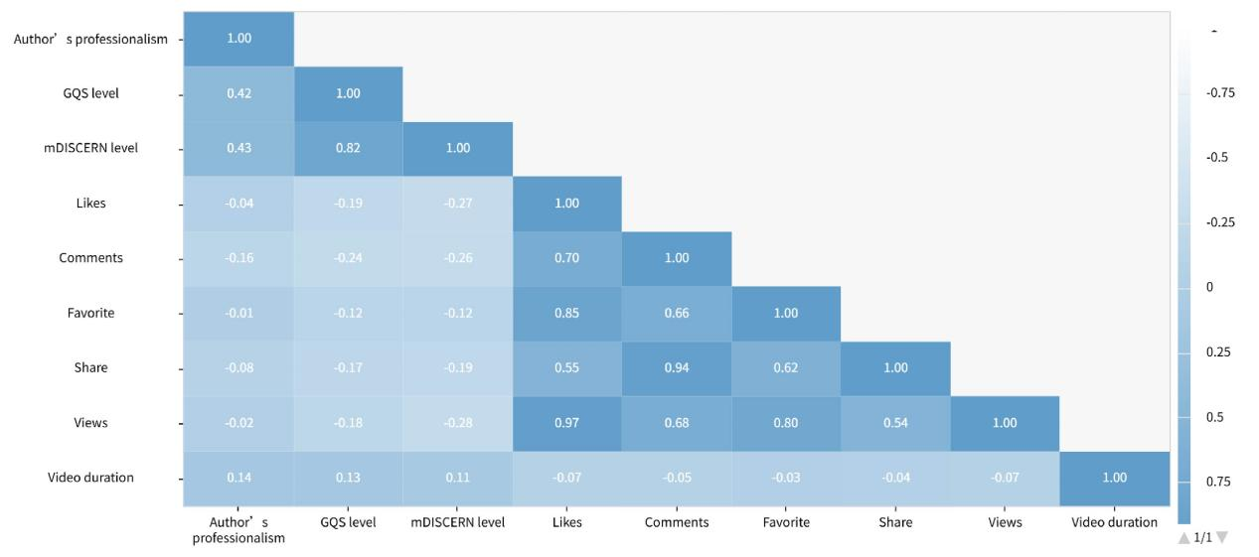

Discussion
DDH remains a major pediatric orthopedic concern, highlighting the need for reliable parental education and early intervention. This study evaluated the quality of DDH-related health information on TikTok and Bilibili, analyzing 125 videos to explore content characteristics, authorship, and engagement. Author professionalism and video duration were positively associated with higher Global Quality Score (GQS) and modified DISCERN (mDISCERN) ratings, while user engagement metrics often correlated negatively with quality, revealing a gap between popularity and scientific accuracy.
TikTok videos were generally shorter and more numerous, primarily created by individual medical professionals, focusing on case reports. Bilibili featured longer, more detailed videos, often from diverse creators, including institutions using animations to enhance comprehension[7, 8]. Professional authorship emerged as the strongest predictor of quality, consistent with prior studies on health communication credibility[9].
A negative correlation between engagement and quality suggests that viral content may prioritize entertainment over accuracy, posing risks for misinformation. Such variability underscores the double-edged nature of short video platforms in health education. Strengthening expert participation, improving content oversight, and promoting evidence-based health communication are essential to enhance the reliability of DDH-related online information and support informed parental decision-making[10].

Conclusion
Our findings reveal that while short video platforms like TikTok and Bilibili have the potential to disseminate health information widely, the quality of content varies significantly. Author professionalism and video length are critical factors in determining content reliability, whereas popular videos often lack scientific rigor. These results emphasize the need for improved quality control and professional oversight in the creation of health content on social media platforms.

Data Availability Statements
The social media data involved in this study were extracted from Bilibili (https://www.bilibili.com) and Tiktok (https://www.douyin.com) websites. The author confirms that all data generated or analysed during this study are included in this published article.

Ethics approval and consent to participate
This study was a cross-sectional analysis of publicly available short videos on TikTok and Bilibili. All data were collected from the public domain and were fully anonymized before analysis. The research did not involve any direct interaction with human participants, nor did it collect or use any private or personally identifiable information. According to the institutional guidelines of Nanjing Medical University, research based exclusively on publicly available data does not require formal ethics approval from an Institutional Review Board (IRB). Therefore, ethics approval was not applicable for this study. Similarly, as no human participants were recruited, the requirement for informed consent was also not applicable. The study was conducted in accordance with relevant ethical guidelines for internet-based research.

Acknowledgement
The authors would like to express their gratitude to the video uploaders for their contributions to public health, as well as to the experts from the Department of Medical Statistics at Nanjing Medical University for their review and assistance in the data analysis of this study. The funding for this study was provided by Children’s Hospital of Nanjing Medical University Incubation Projects (ZHQFH2025004) and General Project of Science and Technology of Nanjing Medical University (NMUB20220023).

Conflicts of interest
The authors have no conflicts of interest to declare.

Author Contributions
Conceptualization, P.Y.; methodology, P.Y.; software, P.Y.; validation, P.Y., Y.T. and L.H.; formal analysis, L.H.; investigation, P.Y.; resources, P.Y.; data curation, P.Y.; writing—original draft preparation, P.Y.; writing—review and editing, L.H.; visualization, Y.T.; supervision, L.H.; project administration, L.H.; funding acquisition, L.H. All authors have read and agreed to the published version of the manuscript.

References
1 Tao Z, Wang J, Li Y, et al. Prevalence of developmental dysplasia of the hip (DDH) in infants: a systematic review and meta-analysis. BMJ Paediatr Open. 2023 Oct;7(1).
2 Vaquero-Picado A, Gonzalez-Moran G, Garay EG, Moraleda L. Developmental dysplasia of the hip: update of management. EFORT Open Rev. 2019 Sep;4(9):548-56.
3 Zhang J, Yuan J, Zhang D, et al. Short video platforms as sources of health information about cervical cancer: A content and quality analysis. PLoS One. 2024;19(3):e0300180.
4 Li B, Liu M, Liu J, Zhang Y, Yang W, Xie L. Quality assessment of health science-related short videos on TikTok: A scoping review. Int J Med Inform. 2024 Jun;186:105426.
5 Lock AM, Baker JF. Quality of YouTube videos for three common pediatric hip conditions: developmental hip dysplasia, slipped capital femoral epiphysis and Legg-Calve-Perthes disease. J Pediatr Orthop B. 2022 Nov 1;31(6):546-53.
6 Liu Z, Chen Y, Lin Y, et al. YouTube/ Bilibili/ TikTok videos as sources of medical information on laryngeal carcinoma: cross-sectional content analysis study. BMC Public Health. 2024 Jun 14;24(1):1594.
7 Liang Y, Xia J, Huo W, et al. Video Quality Assessment and Analysis of Gastroesophageal Reflux Disease on TikTok and Bilibili: Cross-Sectional Study. J Multidiscip Healthc. 2024;17:5927-39.
8 Lim MSC, Molenaar A, Brennan L, Reid M, McCaffrey T. Young Adults' Use of Different Social Media Platforms for Health Information: Insights From Web-Based Conversations. J Med Internet Res. 2022 Jan 18;24(1):e23656.
9 Shi A, El Haddad J, Cai P, et al. Mpox (monkeypox) information on TikTok: analysis of quality and audience engagement. BMJ Glob Health. 2023 Mar;8(3).
10 Guan JL, Xia SH, Zhao K, et al. Videos in Short-Video Sharing Platforms as Sources of Information on Colorectal Polyps: Cross-Sectional Content Analysis Study. J Med Internet Res. 2024 Oct 29;26:e51655.

